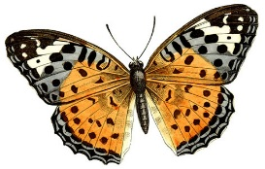

**2nd Grade Newsletter --- Ms. Butkiewicz’s Class**

**April 30- May 4**

***Updates:***

* **NEW Specials Schedules:** 

**Monday- Fun Run**

**Tuesday- No Special**

**Wednesday- P.E.**

**Thursday- Music**

**Friday- Art**

*\*Fun Run activity for Boosterthon is Monday, April 30th. Students will be outside running to earn fundraising for our school. Please be sure that they dress in comfortable clothes and wear appropriate shoes for running. They can also use a water bottle to keep hydrated. Each student will receive a special t-shirt to change into at school in the A.M. Girls may decide to wear a tank top so they slip their fun run shirt over it.*

**\*Homework sheets… Please be sure your child completes homework and reads each night from Book Bag.**

***Learning this Week:***

**Reading: Students will read more scientific texts to make connections, learn new vocabulary and summarize facts and details.**

**Writing: Students will continue narrative writing. Students will write about a time that they learned something new. They will also edit, publish and share their writing this week.**

**Math: Our class is comparing units of measurement, grams, ounces, pounds, and kilograms. We Students will continue to do fun activities as they learn specific measurement strategies.**

**Science: Our live caterpillars are changing into butterflies. We are now studying mapping and geography. This unit will give students practice**